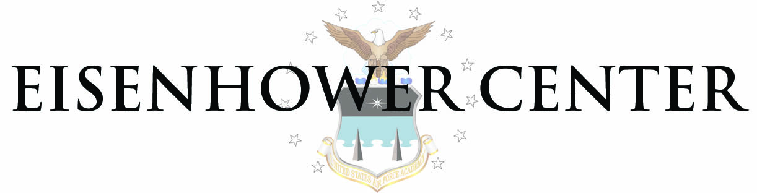
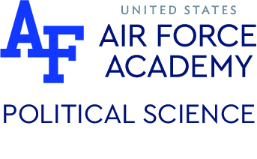
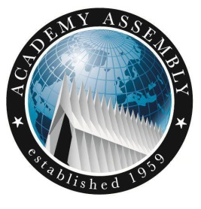

59th Academy Assembly
The Future of American Defense Policy
17-20 October 2017
US Air Force Academy, Colorado Springs

TUESDAY 17 Oct 2017

1300-1720 Arrival of Delegates

1745-1830 Icebreaker Social (Eisenhower Golf Course)

1745 Official Welcome

- Colonel Cheryl Kearney, Permanent Professor Department of Political Science, Air Force Academy

1830 Buses depart for Fairchild Hall

1900 Truman Lecture, Opening Keynote (Fairchild Hall)
- Dr. Hal Brands, Henry A. Kissinger Distinguished Professor of Global Affairs, Johns Hopkins University School of Advanced International Studies

2000 Truman Lecture Reception (CTEF Bridge)

WEDNESDAY 18 Oct 2017

0800 Breakfast/Coffee (Main Hall, McDermott Library)

0830 Panel 1 Principles and Purposes of Defense Policy: Interests, Justice, and
Obligations

0945 Roundtable 1 (Breakout Rooms, McDermott Library)

1130 Lunch (Mitchell Hall)

1230 Panel 2 The International Dimensions of Defense Policy: “Allies and Adversaries” (Regional Groups Meet in Lectinars, Fairchild Hall)

Each panel will have one outside expert, Olmsted Scholar, and USAFA Scholar
Regional Panel Locations

- Europe (L-1)
- Asia (L-3)
- Africa (L-5)
- Mideast (L-2)
- The Americas (L-4)

1430 Roundtable 2 (Breakout Rooms)

1600 Personal Time

1745 Delegate Dinner (Arnold Hall Ballroom)

1900 Keynote Address (Arnold Hall Theater)
- Dr. Heather Wilson, Secretary of the Air Force (invited, option A)

THURSDAY 19 Oct 2017

0800 Breakfast/Coffee

0830 Panel 3 The Evolving Relationship of Defense Policy and Technology
(McDermott Library)

0945 Roundtable 3 (Breakout Rooms)

1130 Buffet Lunch (Arnold Hall Ballroom)

1200 Distinguished Luncheon Speaker (Arnold Hall Ballroom)
- Dr. Michael O’Hanlon, Senior Fellow in Foreign Policy Studies Program, the Brookings Institution.

1330 Panel 4 Defense Policy Choices: The Human and Economic Costs of War
(McDermott Library)

1500 (Delegates) USAFA Mission Element Tours (select one of following)
- Airfield
- FalconSat and CyberWorx
- RPAs & Aero Lab

1500 (Panelists) American Defense Policy Book Discussions (Falcon’s Nest)

1630-1730 Personal Time

1745 Delegate Dinner (Arnold Hall Ballroom)

1900 Keynote Address (Arnold Hall Theater)
- Dr. Heather Wilson, Secretary of the Air Force (invited, option B)

2100-2300 Possible Roundtable 4 (crisis sim concludes)
(Event shifts if no SECAF address)

FRIDAY 20 Oct 2017

0800 Breakfast/Coffee

0830 Defense Policy Outcomes: Defining Victory and Securing Peace
- Dr. Henry Nau, Elliott School of International Affairs, The George Washington University

1015 Roundtable 5 (Team Outbriefs)

1130 Concluding Roundtable Awards and Remarks

1145 Lunch

1230 Delegate Departures begin

~Assembly Concludes~

